COAL LAB MANUAL

**Submitted to:**

Dr. Tauqir

Teacher assistant : Sir Shahzad

**Submitted By:**

Komal Shehzadi

Registeration no : 2016-CS-178

**Section:**

Section B

**Department:**

Department of Computer Science

**Institute:**

University of Engineering and Technology Lahore (Main Campus)



**Date of Submission:** March 29, 2018

# LAB # 3

# Task : Adding two digits and displaying result up to two digits

The description inside the “// ‘ ‘ // “ are the comments to make the code more clear. These are not the part of program.

**// PROGRAM //**

org 100h

**// taking first input from user//**

mov AH, 1

INT 21h

**// storing it in BH register//**

mov BH, AL

sub BH, 30h

**// displaying a newline on screen//**

mov ah, 2

mov dl, 0Ah

INT 21h

**// moving cursor to the start of line//**

mov dl, 0Dh

INT 21h

**// taking 2nd input from user//**

mov ah, 1

INT 21h

**// storing it in BL register in its decimal form by subtracting it from 30h//**

mov BL, AL

sub BL, 30h

**// displaying a new line//**

mov Ah, 2

mov DL, 0Ah

INT 21h

**// adding 2nd input to first input//**

ADD BH, BL

**// making things ready to display on screen//**

mov AH, 2

**// by default div instruction divides something from BL register’s value so we have to divide our value by 10 so moving 10 in bl//**

mov BL, 10

**// clear data in AL and AH so nullify AX//**

mov AL, 00h

mov AH, 00h

mov AL, BH

**// divide AL from BL and split it in AL and AH //**

div BL

**//moving results in suitable registers//**

mov BH, AH

mov BL, AL

**// converting them in decimal form to display on screen//**

add BH, 30h

add BL, 30H

**//displaying BL and BH on screen//**

mov AH, 2

mov DL, BL

int 21h

mov DL, BH

int 21h

ret

## Command:

**Org 100:** Set offset of the segment originated at 100hex

**MOV:** Moves the contents of source instruction in destination and the syntax is as follows:

Mov Destination, Source

**INT 21H:** Call to DOS interrupt Handler

**Sub:** It is used to subtract destination from source and store the result of computation in destination.

Sub Destination, Source

**Add:** It is used to add source in destination and store the result of computation in destination.

Add Destination, Source

**Div:** It is used to Divide source contents by BL register’s contents and store the quotient and remainder of computation in AL and AH register respectively

Div Source

**Ret:** Return statement to end the program

## 

## OUTPUT:

The following output screen will display when we sum 8 and 9 in the above code 3rd line contains the sum of first and 2nd digit.

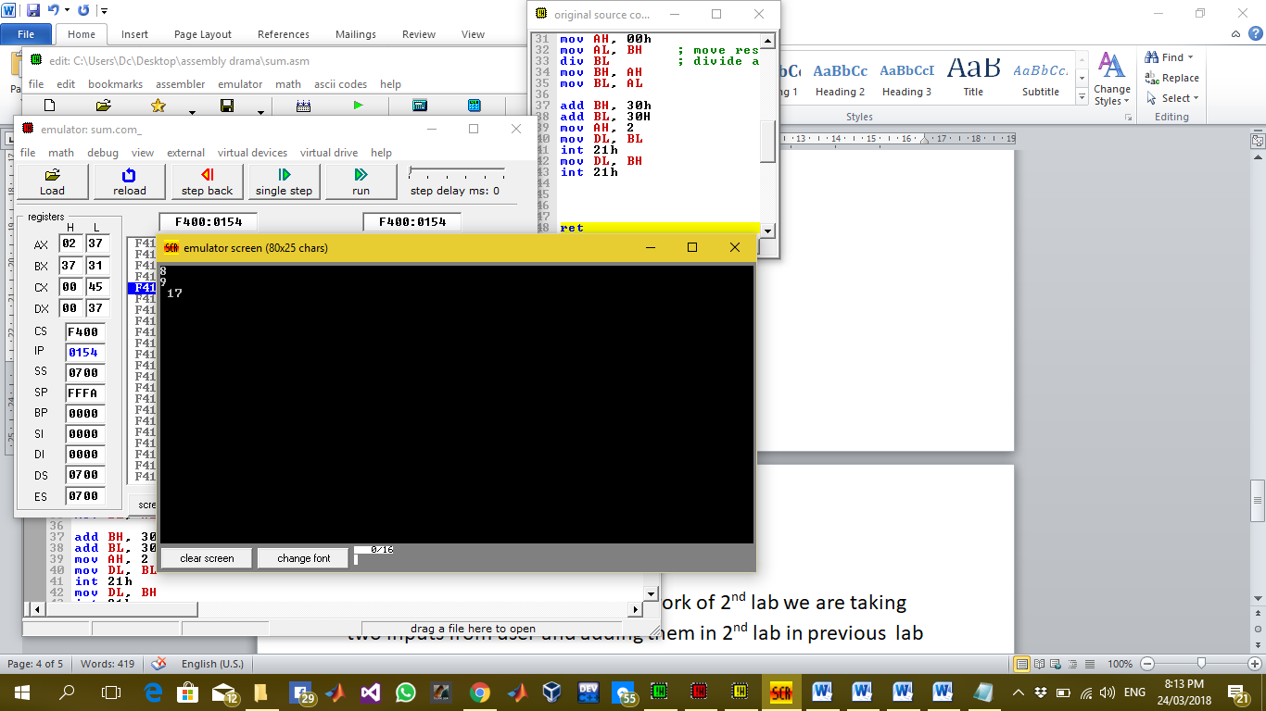

## Description:

In this lab we have extended the work of 2nd lab we are taking two inputs from user and adding them in 2nd lab in previous lab we can only display a single digit on screen as a sum of two inputs but in this lab we can display sum up to two digits maximum 18 on screen when a user enters 9 and 9 to be sum .For this purpose we have used a new command of div to split our digit in two parts and by default the remainder and quotient are stored in AL and AH register respectively div command automatically divides the operand by the contents in BL register so move 10 in BL so that we can get both parts of a digit . And then we can display a two digit number created in a result of arithmetic calculation on screen easily.